**Cross-Browser Compatibility**

* **Comparing on Chrome and Safari**

**Safari**

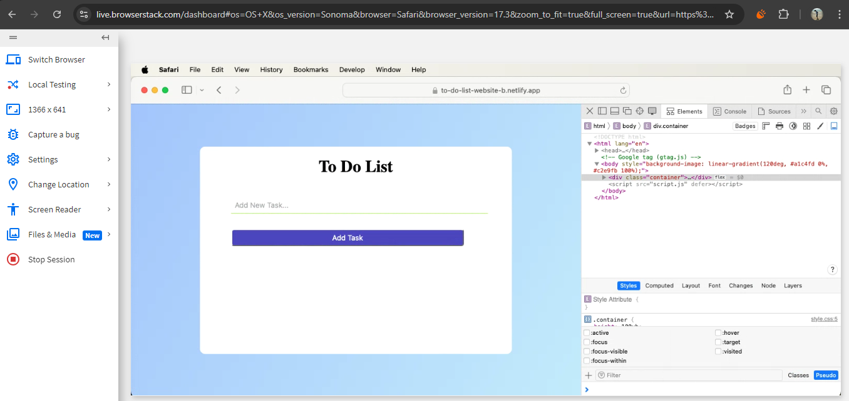

* Works well on Safari Mac
* No issue at all

**Chrome**

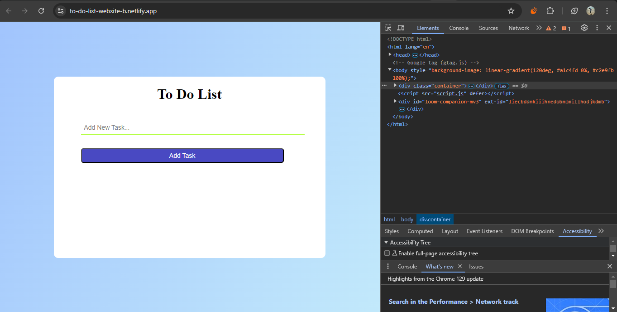

**Browser stack tool is used in this comparison**

* **Debugging and Fixing Compatibility Issues**

**Fixing css :** Flexbox vendor prefixes are added to ensure compatibility with older browsers.

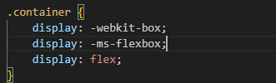

**Fixing js:** add polyfills to make it compatible for older browser version.

